

LSA – 1:1 support

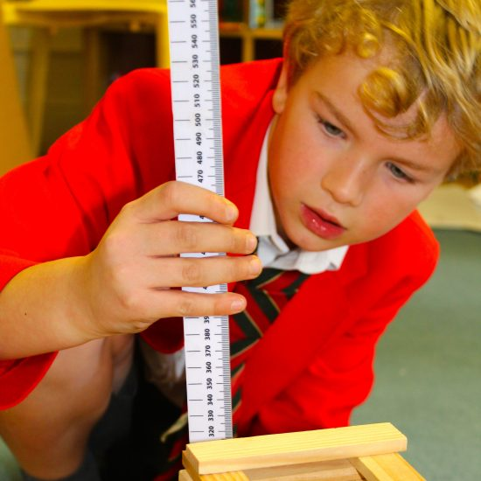

Full/Part Time
Start date – September 2025
Monday to Friday 8:30 to 4pm

Howe Green House is committed to the protection and safety of its pupils and follows safer recruitment practice. If called for interview you will need to bring your driving licence, passport or other photographic ID and original examination documents or certificates for verification. Online searches may be carried out as part of pre-recruitment checks for short listed candidates. The interview will also assess your suitability to work with children and will include questions relating to safeguarding and promoting the welfare of children.

Howe Green House School
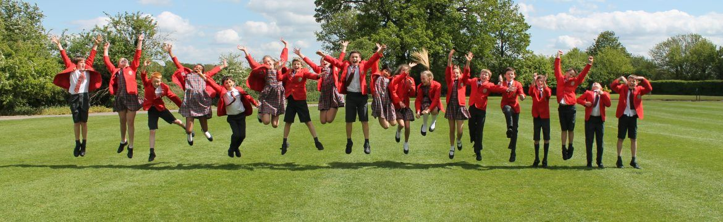

Howe Green House School is a unique environment where children are encouraged, supported and challenged to find their love of learning and stimulate their curiosity of the world.

Our small class sizes and outstanding wellbeing and pastoral care ensures children are not only known individually, but are truly understood and celebrated. The Howe Green House family is a remarkable and dedicated one, and the positivity, kindness and support between each member truly extends outside the school gates.

The children at Howe Green House are immersed in an incredible range of opportunities and are encouraged to try everything on a journey of self-discovery to find their passions – developing resilience and confidence along the way.

Our educational experience starts in Little Oaks Nursery, where the children explore their world and build their knowledge and understanding. These learning connections are then strengthened through the pre-prep and prep school where the wide curriculum allows them to develop their learning skills to be collaborators, problem solvers and decision makers. The children are able to move on to their senior schools of choice with great success and confidence.

JOB DESCRIPTION

LSA – 1:1 support
We are seeking to employ a Learning Support Assistant to work on a 1:1 basis with a child in EYFS. The role will include supporting a child’s learning as directed by the class teacher to ensure that they can access the curriculum to their full potential in a positive, safe and caring learning environment.
Qualifications in learning support or special educational needs and disabilities (SEND) are highly desirable, particularly expertise in speech and language development and phonics.

Responsibilities of the post:
The Learning Support Assistant’s (LSA) main role is to provide 1:1 support for a child. The LSA will ensure that the pupil can integrate as fully as possible in the activities generally undertaken by the other children in the class and make progress. Duties will include running specific programmes and activities to assist the pupil’s individual learning and social needs.

Supporting pupils
- To provide learning support in 1:1 situation.
- To develop knowledge of the particular needs of the child and seek advice from the
SENCo, class teacher and outside agencies as required.
- To aid access to the full range of learning experiences both inside and outside the
classroom and provide modified materials as required e.g. worksheets, games, visual
prompt cards etc.
- To make or modify resources as suggested and advised by the SENCo, Educational
Psychologist or other outside agencies.
- Assist with the organisation of the learning environment.
- Maintain accurate records of the pupils.
- To organise and maintain an inclusive learning environment across the whole school
environment.
- Provide positive reinforcements, praise and rewards to pupils.
- Facilitate inclusion in small group activities with peers and support interaction between
them.
- To attend in training and relevant meetings relevant to the post in order to keep
up to date with developments and best practice.

REQUIREMENTS

 | Requirements | Essential / Desirable
Education / Qualifications and Training | Have GCSE, ‘O’ Level or equivalent qualifications in Maths and English. | Essential
Education / Qualifications and Training | Have NVQ2 or equivalent as recognised by the National Occupational Standards for Supporting Teaching and Learning (NOS-STL). | Desirable
Education / Qualifications and Training | Hold QTS or be a HLTA. | Desirable
Skills and Experience | Have experience of the EYFS curriculum. | Essential
Skills and Experience | Have an interest in how children learn and behave. | Essential
Skills and Experience | Carry out tasks and responsibilities under the direction of the SENCo, Class Teacher, or Head Teacher. | Essential
Skills and Experience | Plan and prioritise tasks and work under the pressure of a busy inclusive primary school. | Essential
Skills and Experience | Have training in aspects of SEN, i.e. Speech and Language. | Desirable
Skills and Experience | Be computer literate. | Essential
Person Specification | Respect and maintain confidentiality but have regard to the safe guarding protocols of information sharing where necessary. | Essential
Person Specification | Use initiative and be able to prioritise tasks. | Essential

