

DIRECTOR OF MUSIC
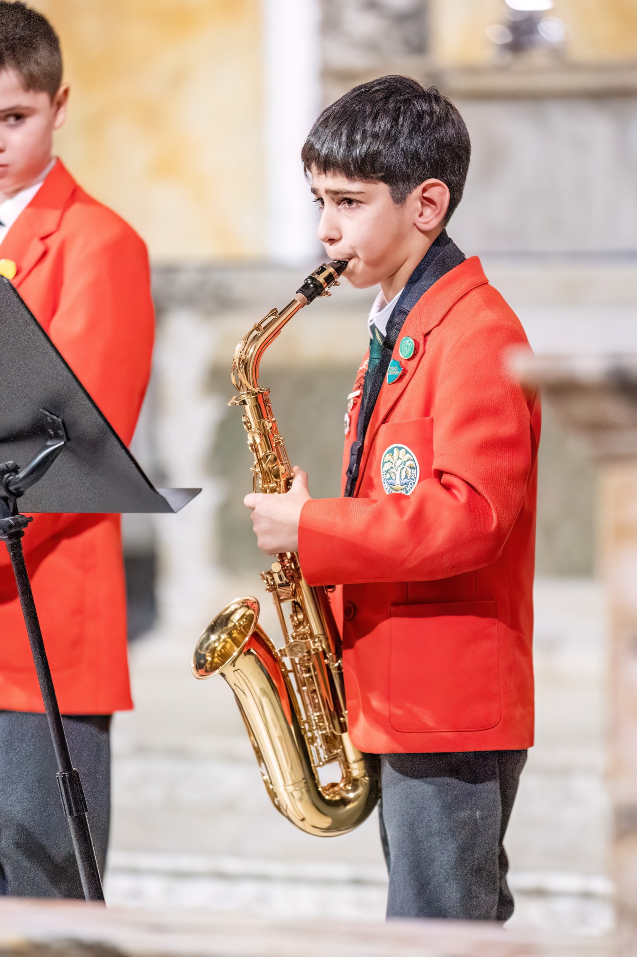

Part Time – Two Days per Week
Start date – September 2025
Salary: based on experience and qualifications
Closing date - 28th March and interviews week commencing 31st March.

Howe Green House is committed to the protection and safety of its pupils and follows safer recruitment practice. If called for interview you will need to bring your driving licence, passport or other photographic ID and original examination documents or certificates for verification. Online searches may be carried out as part of pre-recruitment checks for short listed candidates. The interview will also assess your suitability to work with children and will include questions relating to safeguarding and promoting the welfare of children.

Howe Green House School


Howe Green House School and Little Oaks Nursery is a unique environment where children are encouraged, supported and challenged to find their love of learning and stimulate their curiosity of the world.

Our small class sizes and outstanding wellbeing and pastoral care ensures children are not only known individually, but are truly understood and celebrated. The Howe Green House family is a remarkable and dedicated one, and the positivity, kindness and support between each member truly extends outside the school gates.

The children at Howe Green House are immersed in an incredible range of opportunities and are encouraged to try everything on a journey of self-discovery to find their passions – developing resilience and confidence along the way.

Our educational experience starts in Little Oaks Nursery, where the children explore their world and build their knowledge and understanding. These learning connections are then strengthened through the pre-prep and prep school where the wide curriculum allows them to develop their learning skills to be collaborators, problem solvers and decision makers. The children are able to move on to their senior schools of choice with great success and confidence.

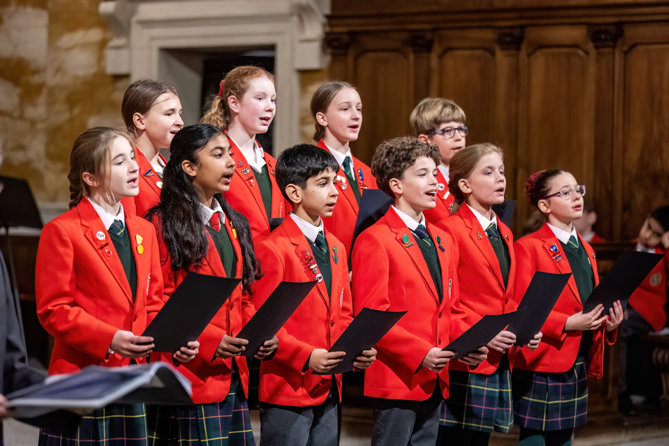

JOB DESCRIPTION

JOB DESCRIPTION
Director of Music / Music teacher – part-time 2 days per week

Howe Green House is a warm, vibrant and thriving prep school, which aims for children of all abilities to flourish academically, physically and creatively – both within and outside of the curriculum.

We are excited to be seeking an outstanding and passionate practitioner to bring a mix of enjoyment and excellence, in equal measure, to the musical life of the school and to ensure that it plays a prominent and important role. It is our view that music should be heard, and felt, throughout the school as the backbeat of its daily existence.

Main Responsibilities – including class teaching
The Director of Music at Howe Green House is responsible for the day-to-day running of the music department; including creating and implementing the policy and practice - and the planning and delivery of an enlivening music scheme of work across the age range.

Peripatetic Music lessons
In addition to class teaching, the Director of Music leads a strong team of peripatetic staff, and would be responsible for the management and expansion of this vital area of the children’s lives. This includes creating the individual lesson timetables and liaising with the school teaching staff to ensure an achievable balance is in place and that school events that impact upon the children’s ability to attend are taken into account.

Wider musical duties – Choirs & instrumental ensembles
Leading the school in small and large choral, orchestral and group ensembles is a large part of the role, which includes accompanying hymns & songs in assemblies and co-leading a variety of school musical productions as well as building upon and conducting a strong orchestra.

There are a variety of school choirs on offer, and the successful candidate would be encouraged to ensure that there were opportunities for children to excel in competitions, as well as to benefit from the joy of communal singing and finding new opportunities to perform to the wider community.

A thriving ‘Parents’ Choir’ operates under the eye of the Director, which performs regularly at school functions.

Extra-curricular
The organisation of extra-curricular activities appropriate to the wide levels of musical experience of the pupils throughout the school to ensure that pupils develop their skills is a fundamental element of the role, and the school is open-minded and eager to embrace new ventures and opportunities.

Events
A variety of school events occur throughout the year and the Director of Music and the music team lead or work as part of the teaching team with the organisation, rehearsal and direction (as a conductor and/or a pianist) of these. i.e.:
- Lower Prep School Lent Term Production
- Upper Prep School Summer Term Production
- Pre-Prep Nativity Production
- The Prep Christmas carol service
- Teatime concerts
- Music for speech and open days

These events represent the current situation – but ideas for additional new opportunities would be warmly encouraged.

General
- Preparing children for music scholarships for their senior schools of choice.
- Make a rota of performers for assemblies & help them prepare for this.
- Develop excellent relationships with the music departments of local senior schools
- Create new opportunities for community outreach – including working with local primary schools.

REQUIREMENTS

 | Requirements | Essential / Desirable
Education / Qualifications and Training | Relevant Degree in Music or Education | Essential
Skills and Experience | Previous experience of working with children | Essential
Skills and Experience | A child-centred approach | Essential
Skills and Experience | Ability to Direct and Conduct Ensembles | Essential
Skills and Experience | An awareness of and compliance with policies and procedures relating to child protection, health and safety, security, confidentiality and data protection | Desirable
Skills and Experience | Ability to Organise Concerts and Events | Essential
Skills and Experience | A flexible approach to work load | Essential
Person Specification | The ability to communicate effectively and politely | Essential
Person Specification | The ability to work as part of a team | Essential
Person Specification | Ability to Engage with Parents and Community | Essential

